**A REPORT ON**

**SENTIMENT ANALYSIS OF COVID-19 TWEETS**

###### **Submitted by**

SUDHA M

MADHUMITHA R

VARSHA NAIR H

KAVERI R

**THIAGARAJAR COLLEGE OF ENGINEERING,**

**MADURAI – 625 015**

**TABLE OF CONTENTS**

|  |  |  |  |  |  |
| --- | --- | --- | --- | --- | --- |
| **1** | |  | **INTRODUCTION** | |  |
|  | |  | 1.1 Overview | |  |
|  | |  | 1.2 Purpose | |  |
| **2** | |  | **LITERATURE SURVEY** | |  |
|  | |  | 2.1 Existing problem | | |
|  | |  | 2.2 Proposed solution | | |
| **3** | |  | **THEORITICAL ANALYSIS** | |  |
|  | |  | 3.1 Block diagram | |  |
|  | |  | 3.2 Hardware / Software designing | | |
| **4** | |  | **EXPERIMENTAL INVESTIGATIONS** | | |
| **5** | |  | **FLOWCHART** | |  |
| **6** | |  | **RESULT** |  |  |
| **7** | |  | **ADVANTAGES & DISADVANTAGES** | | |
| **8** | |  | **APPLICATIONS** | |  |
| **9** | |  | **CONCLUSION** | |  |
| **10** | |  | **FUTURE SCOPE** | | **`** |
| **11** | |  | **BIBILOGRAPHY** | |  |
|  | |  | **APPENDIX** | |  |
|  |  | | 1. Source code | |  |
|  |  | |  |  |  |

**1.INTRODUCTION**

**1.1 OVERVIEW**

The world has been grappling with COVID-19 disease and increasing number of the positive cases made the world grasp attention toward the pandemic. The impact of the outbreak has been so huge that it has been compared to dreaded epidemics and pandemics of the past therefore a tremendous need to address and understand COVID-19’s informational crisis and gauge public sentiment, so that appropriate messaging and policy decisions can be implemented. Our proposed idea is to identify public sentiment associated with the pandemic using Coronavirus specific Tweets with sentiment analysis algorithm. We demonstrate insights into the progress of fear-sentiment over time as COVID-19 approached peak levels all over world, using descriptive textual analytics supported by necessary textual data visualizations. Furthermore, we provide a methodological overview of two essential machine learning (ML) classification methods, in the context of textual analytics, and compare their effectiveness in classifying Coronavirus Tweets. We observe a strong classification accuracy of 91% for short Tweets and 81% accuracy for longer tweets or phrases.

**1.2 PURPOSE**

The coronavirus COVID-19 pandemic is the defining global health crisis of our time and the greatest challenge we have faced since World War Two. Since its emergence in Asia late last year, the virus has spread to [every continent](https://www.undp.org/content/undp/en/home/covid-19-pandemic-response.html#covid19dashboard) except Antarctica.

The scare around this outbreak has traversed across the globe affecting millions of people either through infection or through disruption, stress, worry, fear, disgust, and sadness. This novel virus, has so far killed more than two hundred thousand people and breached borders across the world.

Governments have implemented many measures like social distancing and isolation to prevent the spread of this virus. Social media have become a significant interface to share vital information. The pandemic has been the most trending and talked about issue online, ever since it was first reported in the last week of February 2020.

The proliferation of social media usage for articulation of opinions and feelings by the common public has created possibilities of analysing sentiments about the existing covid-19 outbreak.

**2.LITERATURE SURVEY**

**2.1 EXISTING PROBLEM**

Increasingly stringent measures to keep people apart are put in place to slow the spread of the coronavirus, mental health experts are warning that losing everyday social connections comes with psychological costs. And those costs could go up the longer such measures drag on. the spread of information about the pandemic has been much faster than the virus itself. There has not been one day since the World Health Organization declared it a public health emergency that many messages, memes or videos related to Covid going viral on social media.

In the quarantined days, the people are engaged 24/7 in social media platform such as Facebook, Instagram and most popular Twitter.

Twitter is a popular social media platform with more than 1 million daily active users. Mostly, all breaking news is posted earlier in twitter than any mainstream media. Hence, this microblogging social network experiences a deluge of information flow during epidemics, disasters.

The scare around this outbreak has traversed across the globe affecting millions of people either through infection or through disruption, stress, worry, fear, disgust, and sadness.

Social media have become a significant interface to share vital information. The pandemic has been the most trending and talked about issue online, ever since it was first reported in the last week of February 2020.

The proliferation of social media usage for articulation of opinions and feelings by the common public has created possibilities of analysing sentiments about any dominant trending talks

**2.2 PROPOSED SOLUTION**

Sentiment Analysis is a commonly used text classification technique to analyse any text and it expresses the sentiment of a particular text as positive, negative or neutral.

One of the major types of sentiment analysis is Fine-grained sentiment analysis and One of the major divisions of fine-grained sentiment analysis is Emotion detection. It aims at detecting emotions, like happiness, frustration, anger, sadness, and so on. Many emotion detection systems use lexicons (i.e. lists of words and the emotions they convey) or complex machine learning algorithms.

Sentiment analysis uses various Natural Language Processing (NLP) methods and algorithms.

The algorithms are classified as:

* **Rule-based** systems that perform sentiment analysis based on a set of manually crafted rules.
* **Automatic** systems that rely on machine learning techniques to learn from data.
* **Hybrid** systems that combine both rule-based and automatic approaches.

It is proposed to take the advantage of the developments which has taken place in the information processing to understand the behaviour of the people during this crisis scenario. The tweets related to the Covid pandemic can be extracted from Twitter by identifying the information with the hashtags like #IndiaFightsCorona, #WeartheMask, #CoronaWarriorsIndia.

Systemizing the data extracted from the above tweets, and developing a machine learning model to analyse and understand the behaviour of people if the lockdown is further extended. The results of this classification and predictive model can be used by the government and authorities to come up with useful strategies to solve the most influencing problems for the people.

**3.THEORITICAL ANALYSIS:**

**Block Diagram** :

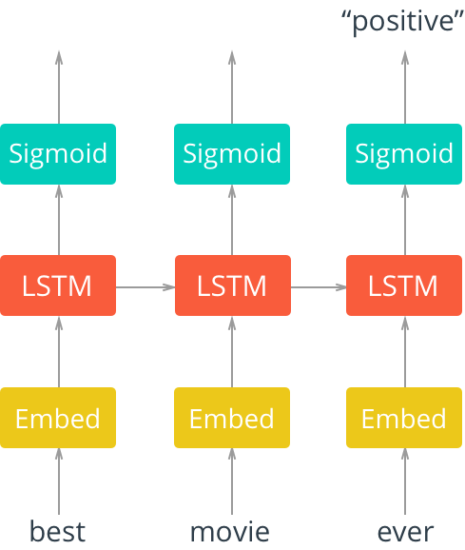

**Hardware/Software Designing :**

We used Node-red tool for wiring APIs along with these methods. Along with Node-red , we made use of Javascript to create the running file and in IBM Cloud , a resource was created and then a toolchain was created for Node-red further. Finally , it has been deployed to IBM Cloud. The Front end UI is designed using HTML and CSS. The site can be accessed by :

<https://node-red-wosva.eu-gb.mybluemix.net/ui/#!/0?socketid=bLotx_yXKfDDIrMzAAAA>

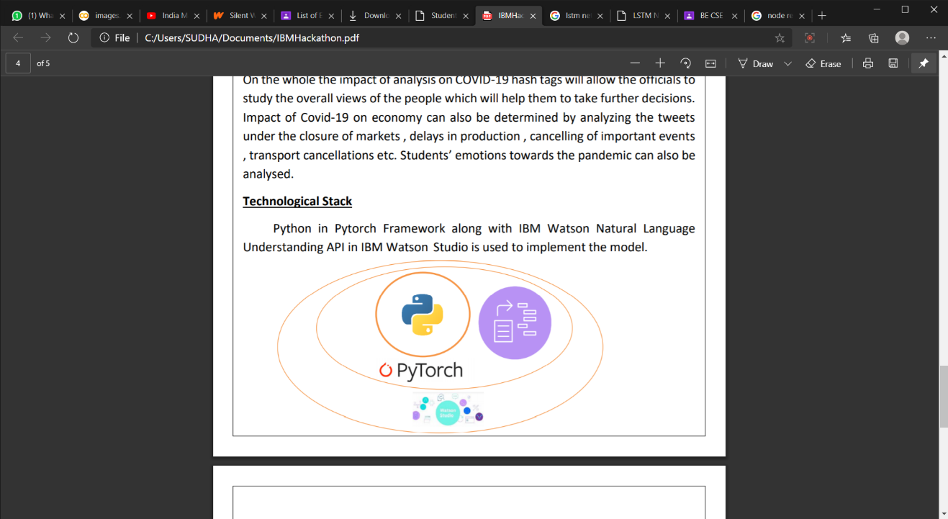

**4.EXPERIMENTAL INVESTIGATIONS :**

After developing the UI , the tests were conducted for Multiple Tweets from Twitter. Here are some samples:

1. “Chennai #COVID cases today is just above 1000 , the infection numbers have reduced nearly 50% compared to last 2 weeks. Well done ! !! Keep up the fantastic work!!”

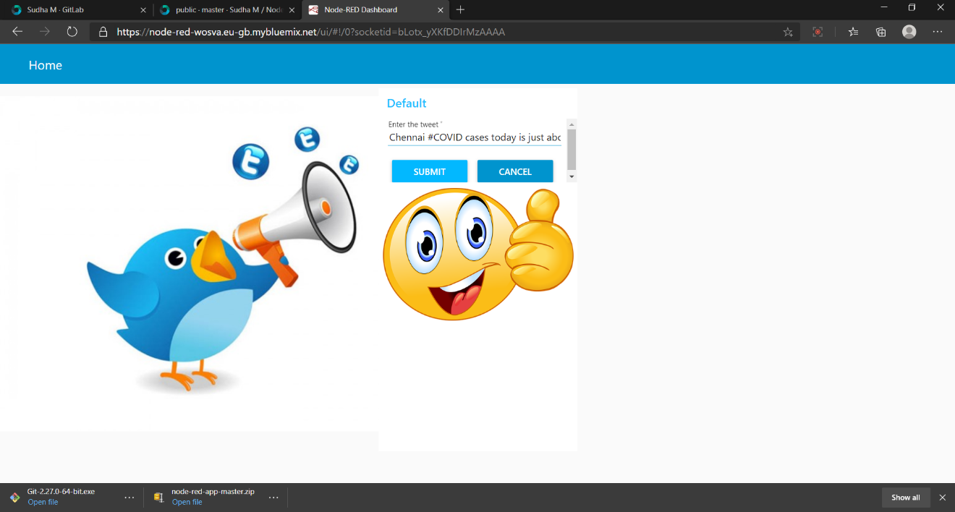

1. “We are in a COVID forest fire without everyone wearing masks and getting plenty of tests for everyone we will not have any water to fight the fire.. We're still waiting in AZ lines in 110 degrees for 8-10 hours to get #COVID tests. Then they shut down early because they run out.”

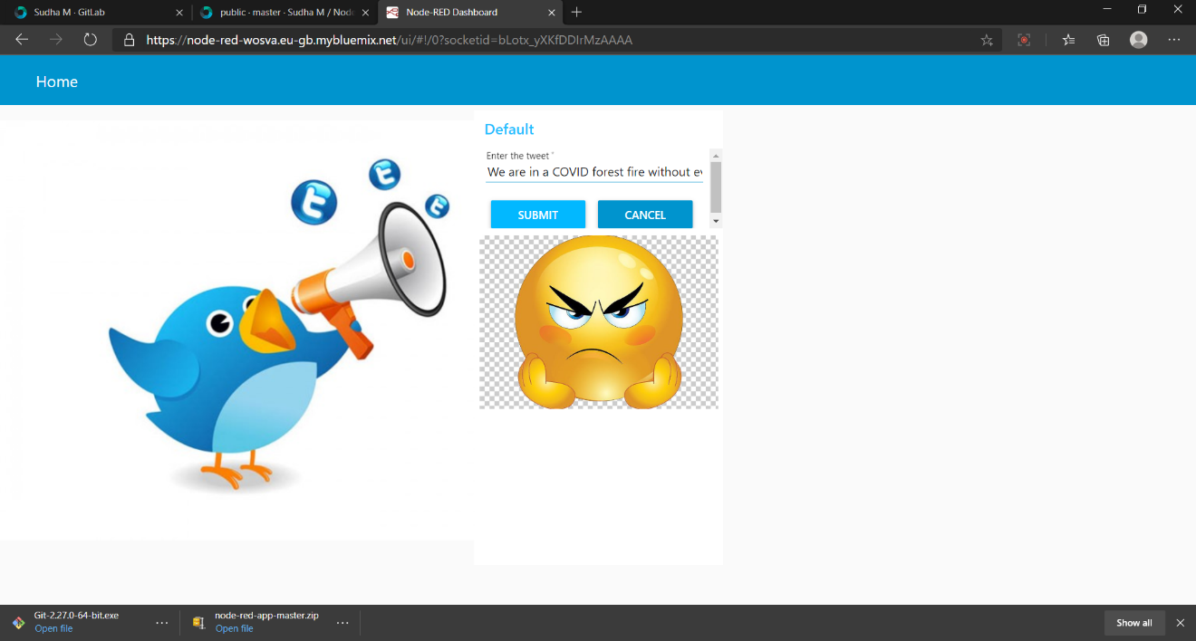

1. 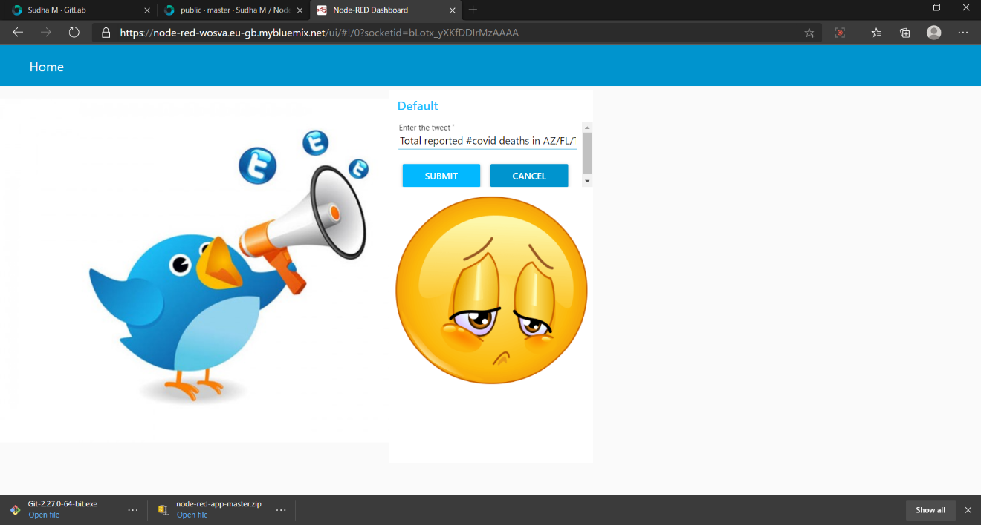“Total reported #covid deaths in AZ/FL/TX (60 million people) yesterday: 123. I know, it’s a Sunday, reporting lags. But deaths yesterday were under 5% of what they were in NY (per-capita) in April. This just is not a catastrophe no matter how hard the media wants to make it one.”

**5. FLOW CHART:**

The flow of our work is represented as follows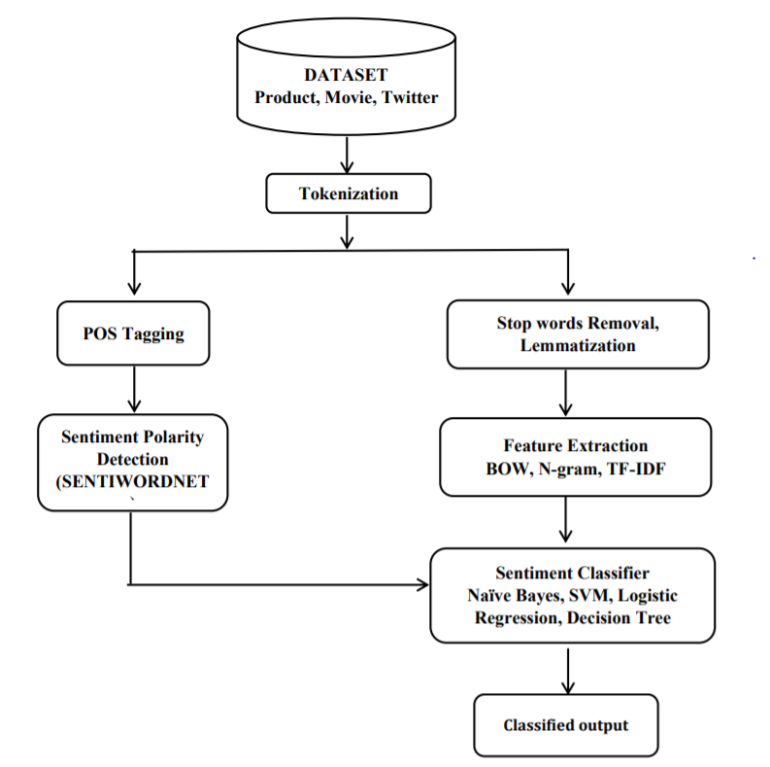

**Explanation:**

The flow of our work can be described as initially a script, python file is created to identify the emotions that occur in the sentence. After that by relating to the sentences the related emoji is displayed. For complete sentimental analysis the dataset has to be got from the twitter and from that sigmoid output can be generated. But this is taken to the future works, and right now the work we have done is for the given input based on sentimental analysis, the accurate emoji is displayed in the user interface, this will enable the user to identify whether the statement is positive negative or even neutral. On the whole, a basic implementation has been done and further linking with twitter database is the future scope of our work.

**6. RESULT:**

The final result we obtained is developing a frontend which will display emoticon relating to the text given in the input box. If the sentence is positive the emoticon representing happy will be generated. Similarly, if the sentence is negative the emoticon representing sad will be generated. Also if the sentence is neutral, then the emoticons relating to it will be displayed. The data here is given as the input by the user. The next step of our work is to fetch the dataset from twitter and based on the types of sentences, a sigmoid output can be displayed. In our case it will be based on the tweets relating to covid-19, so the public’s reaction to different Government policies, action taken by the police, Social activist works, and any other actions regarding COVID -19 can be identified.

Apart from this by understanding the people’s point of view the officials can either continue their policies or take back them. On the whole, till now in our work, the basic sentimental analysis is created which analysis the sentence and can identify the type of sentence and relating to the sentence an emoji is actually displayed.

**7.ADVANTAGES AND DISADVANTAGES:**

Every aspects in this world has a positive and a negative side. [Sentiment analysis](https://www.whoson.com/explore/sentiment-analysis/) is powered by smart language algorithms. In a nutshell, it works by identifying and quantifying the positive and negative feelings within our words. This kind of subtle wordplay can often be lost within the flow of a busy live chat service. Agents are trying their hardest to respond quickly and accurately, and deeper analysis is difficult. The pros and cons of sentiment analysis is listed as follows.

**Advantages:**

### 1. Improve Customer Service

One of the benefits of sentiment analysis is being able to track the key messages from customers’ opinions and thoughts about a brand.

This helps the customer service department to be aware of any related issues or problems.

As the method allows the organizations to understand their customers better, sentiment analysis provides a clear picture of the problems and persuades the organisation to look for a solution.

**2. Develop Quality Products**

Making the customers happy and remain loyal to a brand is a taxing job. Hence another of the benefits of sentiment analysis make the whole process easier and at the same time provides opportunities for improvement.

This allows the marketing team to research the current trends and customers’ preferences better.

The responses from the customers can be used as the guideline to improve the service quality, better future product development, reduce customer churn or improve how the product is presented.

**3. Discovering New Marketing Strategies**

With more data and information gathered through sentiment analysis, the organizations could develop an effective marketing strategy. The outcome from the strategies can be measured from the customers’ positive or negative key messages.

By observing the customers’ conversations on their social media and detect the specific key messages related to your brand, specific marketing campaigns can be designed for the target consumers.

**4. Improve Media Perceptions**

Another benefits of Sentiment Analysis is to be able to track the understanding of the journalists, writers, columnists, market analysts, media researchers or independent contributors towards the company, be it the product, service, company values, human resources etc.

This is crucial as any misinterpretation or negative connotation can lead to negative key messages which forms an undesirable perception.

**5. Increasing Sales Revenue**

Sentiment analysis captures the impressions and moods of the customers and this is definitely a great way to improve sales profits.

As negative key messages are found and the marketing team works their magic to solve the problems and optimize the product quality, organizations can estimate a higher monetary return.

This is achieved by the management’s use of sentiment analysis for improving the products and services. In addition, customers feel that they are being heard and their needs are taken care of, thus improving a company’s image as well.

**6. Improve Crises Management**

Frequent monitoring of the customers’ responses or opinions towards a brand would help to identify any issues quickly; one of the benefits of sentiment analysis.

Avoiding any escalating complaint is one of the purposes of sentiment analysis, which allows for efficient and swift crisis management to be implemented.

Timely preventive actions are very important as it helps to eradicate online communication crisis which could easily spread all over the Internet in minutes.

As sentiment analysis allows organizations to keep a close eye on any negative thread or comments online, potential issues or crises can be dealt with early before escalation.

**Disadvantages:**

While sentiment analysis is useful, we do not believe it is a complete replacement for reading survey responses, as there are often useful nuances in the comments themselves. Where sentiment analysis can help you further is by identifying which of these comments you should read, for example allowing you to focus on the most negative comments.

When asked about the limitations of sentiment analysis, **Russell** said, “Like all opinions, sentiment is inherently subjective from person to person, and can even be outright irrational. It’s critical to mine a large — and relevant — sample of data when attempting to measure sentiment. No particular data point is necessarily relevant. It’s the aggregate that matters. An individual’s sentiment toward a brand or product may be influenced by one or more indirect causes; someone might have a bad day and tweet a negative remark about something they otherwise had a pretty neutral opinion about. With a large enough sample, outliers are diluted in the aggregate. Also, since sentiment very likely changes over time according to a person’s mood, world events, and so forth, it’s usually important to look at data from the standpoint of time.”

Russell continued, “As to sarcasm, like any other type of natural language processing (NLP) analysis, context matters. Analyzing natural language data is, in my opinion, the problem of the next 2-3 decades. It’s an incredibly difficult issue, and sarcasm and other types of ironic language are inherently problematic for machines to detect when looked at in isolation. It’s imperative to have a sufficiently sophisticated and rigorous enough approach that relevant context can be taken into account. For example, that would require knowing that a particular user is generally sarcastic, ironic, or hyperbolic, or having a larger sample of the natural language data that provides clues to determine whether or not a phrase is ironic.”

Despite the possible positive outcomes shown, there are some disadvantages in applying automatic analysis due to the difficulty to implement it because of the ambiguity of natural language and also the characteristics of the posted content. The analysis of tweets is an example of this, for they are usually coupled with hashtags, emoticons and links, creating difficulties in determining the expressed sentiment. In addition, there is a need for automatic techniques that require large datasets of annotated posts or lexical databases where emotional words are associated with sentiment values. Another important aspect is that analyses are suitable for the English language, in which there is a limitation for other languages.

In the field of sentiment analysis are some challenges in a range of scenarios, in terms of architecture and application domains with unclear or scarce datasets. Also, there is a lack of labelled data, which can pose a barrier to the advancements in this area.

**8.APPLICATIONS OF SENTIMENT ANALYSIS:**

## Social Media Monitoring (SMM)

Social media is a goldmine of consumer stories and opinion data. But social posts are full of complex abbreviations, acronyms, and emoticons. Many social analytics platforms can't handle those inconsistencies. The sheer volume is a problem, too. Some social media monitoring tools struggle to scale. Meanwhile, data analysts waste valuable hours parsing mountains of social data by hand.

Lexalytics uses natural language processing (NLP) and machine learning to transform mountains of hashtags, slang, and poor grammar into structured data and useful insights. Data analysts upload, process and analyze mountains of social text data in our platform to understand the conversations surrounding products, brands, people and services. Technology companies integrate our NLP APIs into their social listening product to deliver better insights to their own customers.

**Voice of Customer (VoC) & Customer Experience Management:** Great customer experiences add 4-8% revenue, 6-14x higher lifetime value and up to 55**%** greater retention. Meanwhile **,**gaining a new customer costs 5-8x more than retaining an existing one. Customer Experience Management and Voice of Customer programs bring together product management, customer support, and engineering teams to understand customer needs, improve customer satisfaction and deliver better products. But building an effective **VO**C program is not a simple task. Consider the volume of data out there: hundreds of customer surveys, thousands of reviews, millions of social media comments. Manual analysis is too slow and expensive.

Voice of Customer tools like the Lexalytics Intelligence Platform use natural language processing and sentiment analysis to transform customer feedback into structured data and useful insights at scale. We help you understand how people perceive and interact with your brands, products, and services, so you can make better decisions and recommendations across your company.

## Robotic Process Automation: Robotic Process Automation (RPA) vendors must meet increasing customer demands for larger, transformational RPA and deeper analytics integrations. But many firms are lagging behind in supporting trending text analytics use cases. Others have stronger text analytics but lack capabilities with “unstructured document use cases” involving PDFs. And still others are having trouble fitting text analytics and natural language processing components into their larger environment.

Lexalytics helps you solve these problems with easy-to-integrate text analytics solutions that are stable, scalable, and completely customizable. Add our tools to your own RPA platform to quickly address outstanding text analytics use cases, deliver better analytics capabilities and differentiate your offerings in the rapidly evolving RPA marketplace.

## People Analytics & Voice of Employee:

Employee turnover is at a record-high. Companies are struggling to improve employee engagement and morale. Meanwhile, unhappy employees create bad customer experiences. The result? $62 billion in lost revenue for U.S. businesses each year. To turn the tide, data-driven HR organizations are implementing comprehensive People Analytics programs. McKinsey & Co. finds that People Analytics can [improve recruiting efficiency by 80%](https://www.mckinsey.com/solutions/orgsolutions/overview/people-analytics), raise productivity by 25%, and reduce attrition by 50%.

Within the People Analytics framework, Voice of Employee programs gather, analyze and interpret employee feedback to uncover the factors that drive down employee engagement and loyalty.

**9.CONCLUSIONS:**

The rise of social media has fuelled interest in sentiment analysis. Promptly and correctly classifying sentiment from the text has become an important task for individuals and companies. In the development of prediction models to classify the reviews, more reliable approaches are expected to reduce the misclassifications. In this study, the results of various hybrid methods are empirically evaluated on datasets of different size for use in sentiment mining. Among the methods used, hybrid ensemble method (HEM1) is highly robust in nature for balanced data models I, II and III, which is studied through various quality parameters. The analysis also shows that the compound combination of unigram, bigram and trigram performs better for almost all the prediction methods. To handle imbalance data distribution in real time applications, it is observed from the results that using SVMs for class prediction can be influenced by the data imbalance, although SVMs can adjust itself well to some degree of data imbalance. To cope with the problem, rebalancing the data is chosen as a promising direction, but both under sampling and over sampling have limitations. Through extensive experiments with benchmark and real application datasets, the proposed modified bagging method is shown to be effective and superior to several other methods with different data sampling methods. The results also proved that the PCA is a suitable dimension reduction method for hybrid methods for both balanced and imbalanced datasets.

Despite all the challenges and potential problems that threatens Sentiment analysis, one cannot ignore the value that it adds to the industry. Because Sentiment analysis bases its results on factors that are so inherently humane, it is bound to become one the major drivers of many business decisions in future. Improved accuracy and consistency in text mining techniques can help overcome some current problems faced in Sentiment analysis. Looking ahead, what we can see is a true social **democracy** that will be created using Sentiment analysis, where we can harness the wisdom of the crowd rather than a select few “experts”. A democracy where every opinion counts and every sentiment affects decision making. Here in our project we have made a general sentiment analysis in which output is produced from the segregated adjectives from the input and the emoticons is displayed as an output. This project has several future scope.

**10.FUTURE SCOPE:**

The **future** of **sentiment analysis** is going to continue to dig deeper, far past the surface of the number of likes, comments and shares, and aim to reach, and truly understand, the significance of social media interactions and what they tell us about the consumers behind the screens.

Sentiment analysis methods till now have been used to detect the polarity in the thoughts and opinions of all the users that access social media. Sentiment analysis has tremendous applications in many fields. Among them the chosen field is social media monitoring. The model will be further extended to segregate the tweets as positive, negative and neutral by applying LSTM architecture and display it as a sigmoid output. The Proposed model is limited to English tweets and further this can be aggrandized to other non-English tweets. This model can also be further extended to global tweets. In future, the effect of various other feature reduction techniques like latent dirchlet allocation can be investigated. Further experiments should be conducted in the future to evaluate the impact of various domain and region specific parameters. Extending sentiment mining to other domains may lead to interesting new results. In future, the use of more combination of n-grams and feature weighting that gives a better accuracy level than this can be considered. The work done in this research is only related to classification sentiment into two of the classes (binary classification) that is a positive class and negative class. In the future development, a multiclass of sentiment classification such as positive, negative, neutral and so on might be taken into consideration. In this work, the focus is on finding features that appear explicitly as nouns or noun phrases in the reviews. The finding of implicit features is left to future work. As ensemble learning methods need a lot of computing time, parallel computing techniques should be explored to tackle this problem. A major limitation of ensemble learning methods is the lack of interpretability of the results and the knowledge learned by ensembles is difficult for humans to understand. Therefore improving the interpretability of ensembles is another important research direction. Future opinion-mining systems need broader and deeper common and common sense knowledge bases. This will lead to a better understanding of natural language opinions and will more efficiently bridge the gap between multimodal information and machine process able data. Blending scientific theories of emotion with the practical engineering goals of analyzing sentiments in natural language text will lead to more bio-inspired approaches to the design of intelligent opinion-mining systems capable of handling semantic knowledge, making analogies, learning new affective knowledge, and detecting, perceiving, and “feeling” emotions.

**Source Code**

|  |
| --- |
| <!DOCTYPE html> |
|  | <html lang="en"> |
|  | <head> |
|  | <meta http-equiv="Content-Type" content="text/html; charset=utf-8" /> |
|  | <meta name="viewport" content="width=device-width, initial-scale=1.0"> |
|  | <title>Node-RED on IBM Cloud</title> |
|  | <link href='https://fonts.googleapis.com/css?family=Roboto+Slab:400,700,300,100' rel='stylesheet' type='text/css'> |
|  | <link href="css/simplegrid.css" rel="stylesheet" media="screen"> |
|  | <link href="css/style.css" rel="stylesheet" media="screen"> |
|  | </head> |
|  |  |
|  |  |
|  | <body> |
|  |  |
|  | <div class="header"> |
|  | <div class="header-content"> |
|  | <div class="brand">Node-RED on IBM Cloud</div> |
|  | </div> |
|  | </div> |
|  | <!-- Grid 1 --> |
|  | <div class="title"> |
|  | <div class="grid"> |
|  | <div class="col-1-1"> |
|  | <div class="content"> |
|  | <h1>Node-RED</h1> |
|  | <h2>Flow-based programming for the Internet of Things</h2> |
|  | </div> |
|  | </div> |
|  | </div> |
|  | </div> |
|  |  |
|  | <!-- Grid 1/2 --> |
|  | <div class="row2"> |
|  | <div class="grid"> |
|  | <div class="col-1-2"> |
|  | <div class="content blurb"> |
|  | <p>Node-RED is a programming tool for wiring together hardware devices, APIs and online services in new and interesting ways.</p> |
|  | <p>This instance is running as an IBM Cloud application, giving it access to the wide range of services available on the platform.</p> |
|  | <p>More information about Node-RED, including documentation, can be found at <a href="https://nodered.org">nodered.org</a>.</p> |
|  | </div> |
|  | </div> |
|  | <div class="col-1-2"> |
|  | <div class="content blurb"> |
|  | <p style="text-align: center"><a style="width:350px;" class="button" href="red/">Go to your Node-RED flow editor</a></p> |
|  | <p style="text-align: center"><a href="#custom">Learn how to customise Node-RED</a></p> |
|  | </div> |
|  | </div> |
|  | </div> |
|  | </div> |
|  |  |
|  | <!-- Grid 1/2 --> |
|  | <div class="row3"> |
|  | <div class="grid"> |
|  | <div class="col-1-1"> |
|  | <div class="content blurb"> |
|  | <h3 id="custom">Customising your instance of Node-RED</h3> |
|  | <p>This instance of Node-RED is enough to get you started creating flows.</p> |
|  | <p>You may want to customise it for your needs, for example replacing |
|  | this introduction page with your own, adding http authentication to the flow editor or adding new nodes to |
|  | the palette. |
|  | </p> |
|  | <p>To start customising your instance of Node-RED, you can either download the application locally or use IBM DevOps Services to edit and deploy your changes directly.</p> |
|  | <ul class="customisations"> |
|  | <li> |
|  | <h4 id="securing-the-editor"> + Securing the editor</h4> |
|  | <div class="custom-content"> |
|  | <p>When you first ran this application you were presented with some options to secure the editor. To change those options, |
|  | you can set some environment variables from either the Bluemix console or the <code>cf</code> command-line |
|  | </p> |
|  | <p>The environment variables you can set are:</p> |
|  | <ul> |
|  | <li><code>NODE_RED_USERNAME</code> - the username to secure the editor with</li> |
|  | <li><code>NODE_RED_PASSWORD</code> - the password to secure the editor with</li> |
|  | <li><code>NODE_RED_GUEST_USER</code> - set to <code>true</code> to allow anonymous users to have read-only access to the editor</li> |
|  | </ul> |
|  |  |
|  | <h5>Bluemix console</h5> |
|  | <ol> |
|  | <li>On the Bluemix console page for this application, go to the 'Runtime' page and then the 'Environment Variables' section</li> |
|  | <li>Add the required user-defined variables</li> |
|  | <li>Click <code>Save</code> and restart your application</li> |
|  | </ol> |
|  | <h5><code>cf</code> command-line</h5> |
|  | <ol> |
|  | <li>Run the command: <pre>cf set-env [APPLICATION_NAME] [ENV_VAR_NAME] [ENV_VAR_VALUE]</pre></li> |
|  | </ol> |
|  | </div> |
|  | </li> |
|  | <li> |
|  | <h4 id="enabling-appmetrics"> + Enabling Application Metrics for Node.js monitoring</h4> |
|  | <div class="custom-content"> |
|  | <p>When you first ran this application you were presented with an option to enable monitoring of your Node-RED |
|  | flows using the <a href="https://developer.ibm.com/node/monitoring-post-mortem/application-metrics-node-js/" target="_blank">Application Metrics for Node.js</a> |
|  | dashboard. To change those options, you can set an environment variable from either the Bluemix console or the <code>cf</code> command-line |
|  | </p> |
|  | <p>When enabled, the <a href="https://developer.ibm.com/node/monitoring-post-mortem/application-metrics-node-js/" target="_blank">Application Metrics for Node.js</a> dashboard will be available at </p> |
|  | <p id="appdashURL"></p> |
|  | <p>The environment variable you can set is:</p> |
|  | <ul> |
|  | <li><code>NODE_RED_USE_APPMETRICS</code> - set to <code>true</code> to enable <a href="https://developer.ibm.com/node/monitoring-post-mortem/application-metrics-node-js/" target="_blank">Application Metrics for Node.js</a> |
|  | monitoring. Set to <code>false</code> to disable. |
|  | </li> |
|  | </ul> |
|  | <h5>Bluemix console</h5> |
|  | <ol> |
|  | <li>On the Bluemix console page for this application, go to the 'Runtime' page and then the 'Environment Variables' section</li> |
|  | <li>Add the required user-defined variable</li> |
|  | <li>Click <code>Save</code> and restart your application</li> |
|  | </ol> |
|  | <h5><code>cf</code> command-line</h5> |
|  | <ol> |
|  | <li>Run the command: <pre>cf set-env [APPLICATION_NAME] [ENV_VAR_NAME] [ENV_VAR_VALUE]</pre></li> |
|  | </ol> |
|  | </div> |
|  | </li> |
|  | <li> |
|  | <h4> + Adding new nodes to the palette</h4> |
|  | <div class="custom-content"> |
|  | <p>There is a growing collection of additional nodes that can be added to the Node-RED editor. |
|  | You can search for available nodes on the <a target="_blank" href="https://flows.nodered.org">Node-RED library</a>. |
|  | </p> |
|  | <p>To add a node to the editor you can either use the Palette Manager feature within the editor itself or manually edit the <code>package.json</code> file.</p> |
|  | <h5>Palette Manager</h5> |
|  | <ol> |
|  | <li>Within the editor, select the Manage Palette option from the drop-down menu</li> |
|  | <li>Go to the Install tab</li> |
|  | <li>Search for the module you're interested in and click <code>install</code></li> |
|  | </ol> |
|  | <h5>Edit <code>package.json</code></h5> |
|  | <ol> |
|  | <li>Edit the file <code>package.json</code> and add the required node package to the <code>dependencies</code> |
|  | section. The format is: |
|  | <pre>"node-red-node-package-name":"x.x.x"</pre> |
|  | Where <code>x.x.x</code> is the desired version number. |
|  | </li> |
|  | </ol> |
|  | </div> |
|  | </li> |
|  | <li> |
|  | <h4> + Upgrading the version of Node-RED</h4> |
|  | <div class="custom-content"> |
|  | <p>The application's <code>package.json</code> is setup to grab the latest stable release of Node-RED.</p> |
|  | <p>To trigger an upgrade following a new release being made available:</p> |
|  | <ol> |
|  | <li>Set the <code>NODE_MODULES_CACHE</code> environment variable to <code>false</code>. You can either |
|  | do this on your application's Bluemix console page (Runtime -&gt; Environment Variables), or by |
|  | using the <code>cf</code> command-line: |
|  | <pre>cf set-env [APPLICATION_NAME] NODE_MODULES_CACHE false</pre> |
|  | </li> |
|  | <li>Trigger a restage of your application. This cannot be done using the Bluemix console, so the <code>cf</code> |
|  | command-line should be used: |
|  | <pre> cf restage [APPLICATION_NAME]</pre> |
|  | </li> |
|  | </ol> |
|  | </div> |
|  | </li> |
|  | <li> |
|  | <h4> + Changing the static web content</h4> |
|  | <div class="custom-content"> |
|  | <p>The page you are reading now is served as static content from the application. This can be replaced |
|  | with whatever content you want in the <code>public</code> directory. |
|  | </p> |
|  | </div> |
|  | </li> |
|  | <li> |
|  | <h4> + Remove static web content and serve the flow editor from the root path</h4> |
|  | <div class="custom-content"> |
|  | <p>In the file <code>bluemix-settings.js</code>, delete the <code>httpStatic</code> and <code>httpAdminRoot</code> entries.</p> |
|  | </div> |
|  | </li> |
|  | </ul> |
|  | </div> |
|  | </div> |
|  | </div> |
|  | </div> |
|  |  |
|  | <div class="links"> |
|  | <div class="grid"> |
|  | <div class="col-1-3"> |
|  | <p><a href="https://nodered.org">Node-RED</a> is a visual wiring tool for the Internet of Things.</p> |
|  | <p>A project of the <a href="https://js.foundation/">JS Foundation</a>.</p> |
|  | </div> |
|  | <div class="col-1-6"> |
|  | <ul> |
|  | <li><a href="https://github.com/node-red">GitHub</a></li> |
|  | <li><a href="https://www.npmjs.com/package/node-red">npm</a></li> |
|  | <li><a href="https://nodered.org/docs">Documentation</a></li> |
|  | </ul> |
|  | </div> |
|  | <div class="col-1-6"> |
|  | <ul> |
|  | <li><a href="https://flows.nodered.org">Flow Library</a></li> |
|  | <li><a href="https://nodered.org/about/">About</a></li> |
|  | </ul> |
|  | </div> |
|  | <div class="col-1-6"> |
|  | <ul> |
|  | <li><a href="https://nodered.org/blog/">Blog</a></li> |
|  | <li><a href="https://twitter.com/nodered">Twitter</a></li> |
|  | <li><a href="https://groups.google.com/forum/#!forum/node-red">Mailing List</a></li> |
|  | <li><a href="https://nodered.org/slack">Slack</a></li> |
|  | </ul> |
|  | </div> |
|  | </div> |
|  | </div> |
|  | <script src="https://code.jquery.com/jquery-1.12.4.min.js"></script> |
|  | <script> |
|  | var appdashURL = $("#appdashURL"); |
|  | var urlString = location.origin + "/appmetrics-dash"; |
|  | appdashURL.empty(); |
|  | $('<a href="' + urlString + '" target="_blank">' + urlString + '</a>').appendTo(appdashURL); |
|  |  |
|  | $(function() { |
|  | $("ul.customisations h4").click(function(ev) { |
|  | $(this).next('.custom-content').slideToggle(); |
|  | }); |
|  | }); |
|  | </script> |
|  | </body> |
|  | </html> |